4MU | Monday | Tuesday | Wednesday | Thursday | Friday
9:15 – 9:30  Pastoral | Assembly  Hall | Pastoral  Room 1 | Pastoral  Room 1 | Hymn Practice  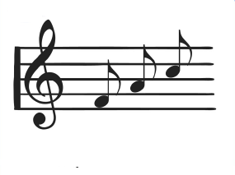  Hall | Assembly  Hall
9:30 – 10:15  Lesson 1 | English  Room 1 | Careers  Room 9 | Science  Room 8 | Library  Library  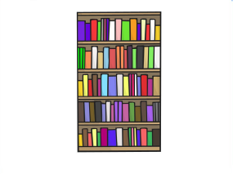 | English Reflection  Room 1
10:15 – 11:00  Lesson 2 | English  Room 1 | English  Room 10 | Science  Room 8  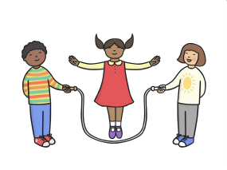 | Science  Room 8 | English  Room 1
11:00 – 11:15
Break
11:15 – 12:10  Lesson 3 | Maths  Room 1 | Maths  Room 1 | Maths  Room 1 | Maths  Room 1 | English  Room 1
12:10 – 1:00
Lunchtime
1:00 – 1:45  Lesson 4 | Computing  Room 1 | KS4  Leisure | KS4  Options | KS4  Options | PSD  Room 6
1:45 – 2:30  Lesson 5 | Computing  Room 1 | KS4  Leisure | KS4  Options | KS4  Options | PSD  Room 6
2:30 – 3:10  Lesson 6 | PSHCE/SEAL  Room 1 | KS4  Leisure | KS4  Option | KS4  Options | PSD  Room 6
3:15
Home Time
Weatherfield Academy 2017 - 2018
Weatherfield Academy 2015-2016
Weatherfield Academy 2015-2016

