CBC SEND Parent & Young Person Partnership Service
(Formerly Parent Partnership)
Independent Support in Central Bedfordshire

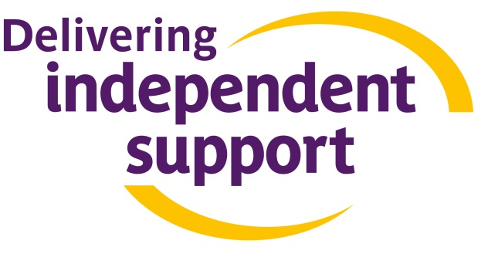

Is your child or young person having their Statement of Special Educational Needs or Learning Difficulties Assessment transferred to an Education Health and Care (EHC) Plan?
Do you want to know how you as a parent, carer or young person can play a key role in producing your EHC Plan?
Do you want to find out more about how to request an assessment for an EHC Plan, or find out more about the process or about Personal Budgets?
The Central Bedfordshire SEND Parent & Young Person Partnership Service and Core Assets Children’s Services are jointly delivering the new ‘Independent Support Service’ in Central Bedfordshire. We are here to provide confidential, impartial and independent information and support. Our service helps families and young people (aged 0 to 25 years) to find their way through the changes to the Special Educational Needs and Disabilities (SEND) system. In particular we can support you through the new EHC Needs assessment process and the transfer from statements and Learning Difficulty Assessments to Education, Health and Care Plans. This is a FREE service and we are here to help and support young people and their families.
We can provide you with information and support in a variety of ways:
- Individual face to face. We can provide support from a dedicated Independent Supporter in a place and at a time to suit you
- Telephone Helpline. To speak to someone about getting help from an Independent Supporter you can ring 0300 300 8088 between 7.30am and 4pm Monday to Friday or
0800 028 8455 between 4pm and 9pm Monday to Friday, and 9am to 5pm on Saturdays and Sundays. If for any reason you are unable to speak to someone, please leave a message and we will respond to you as quickly as we can.
- Via the internet. Visit our websites for useful and helpful information:
www.coreassets.com/what-we-do/independent-support-service
www.centralbedfordshire.gov.uk/parentpartnership
- Email support. You can email us at:
ISreferrals@coreassets.com or complete the online contact form
Parent.partnership@centralbedfordshire.gov.uk
- Open access/drop in sessions. We provide ‘Outreach’ information and support points in the community – please make contact for more information
Both services are independent organisations that have been working with children and families for many years. We are passionate about working together to improve outcomes for children, young people and their families.

