4TM | Monday | Tuesday | Wednesday | Thursday | Friday
9:15 – 9:30  Pastoral | Assembly  Hall | Pastoral  Room 11 | Pastoral  Room 11 | Hymn Practice  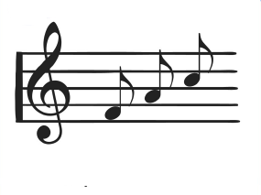  Hall | Assembly  Hall
9:30 – 10:15  Lesson 1 | English  Room 11 | Computing  Room 1 | Library  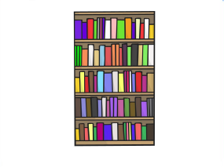  Library | Careers  Room 16 | English Reflection  Room 11
10:15 – 11:00  Lesson 2 | English  Room 11 | Computing  Room 1 | Maths  Room 11  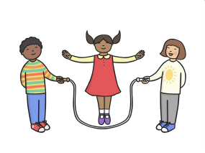 | English  Room 6 | English  Room 11
11:00 – 11:15
Break
11:15 – 12:10  Lesson 3 | Maths  Room 11 | Science  Room 8 | Maths  Room 11 | Maths  Room 11 | English  Room 11
12:10 – 1:00
Lunchtime
1:00 – 1:45  Lesson 4 | Science  Room 8 | KS4  Leisure | KS4  Options | KS4  Options | PSD  Room 16
1:45 – 2:30  Lesson 5 | Science  Room 8 | KS4  Leisure | KS4  Options | KS4  Options | PSD  Room 16
2:30 – 3:10  Lesson 6 | PSHCE/SEAL  Room 11 | KS4  Leisure | KS4  Options | KS4  Options | PSD  Room 16
3:15
Home Time
Weatherfield Academy 2017 - 2018
Weatherfield Academy 2015-2016
Weatherfield Academy 2015-2016

