8JL | Monday | Tuesday | Wednesday | Thursday | Friday
9:15 – 9:30  Pastoral | Pastoral  Room 16 | Pastoral  Room 16 | Assembly  Hall | Hymn Practice  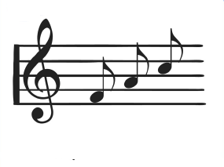  Hall | Assembly  Hall
9:30 – 10:15  Lesson 1 | English  Room 16 | English  Room 16 | Rural Studies  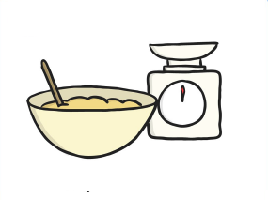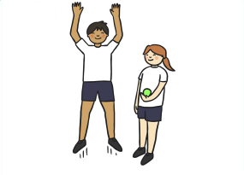  Farm | DT  Room 11 | English Reflection  Room 16
10:15 – 11:00  Lesson 2 | English  Room 16  DT | English  Room 16 | Rural Studies  Farm | DT  Room 11 | English  Room 16
11:00 – 11:15  Break |  | 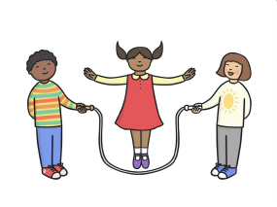
11:15 – 12:05  Lesson 3 | Maths  Room 16 | Maths  Room 16 | Maths  Room 16 | Maths  Room 16 | Maths  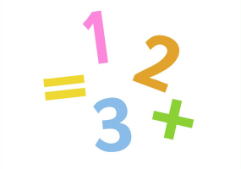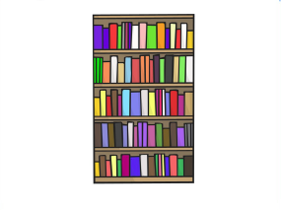  Room 16
12:05 – 1:00
Lunchtime
1:00 – 1:45  Lesson 4 | Art  Room 10 | Library  Library | Computing  Room 1 | Humanities  Room 12 | Food  Room 9
1:45 – 2:30  Lesson 5 | Art  Room 10 | Science  Room 8 | Computing  Room 1 | Humanities  Room 12 | Food  Room 9
2:30 – 3:10  Lesson 6 | PSHCE/SEAL  Room 16 | Science  Room 18 | PE  Hall | PE  Hall | Music  GS2
3:15
Home Time
Weatherfield Academy 2017 - 2018
Weatherfield Academy 2015-2016
Weatherfield Academy 2015-2016

