Equine Therapy

What is equine therapy and how does it help in the treatment of mental health conditions and learning disabilities?
Caring for and interacting with animals has many proven health benefits. As it provides people with companionship, comfort and a strong sense of wellbeing, it’s no surprise that animals have been used for therapeutic purposes throughout history.
Whilst a range of animals can be used in therapy, including dogs, cats, guinea pigs and even fish, equine therapy (therapy involving horses) has been found to be particularly effective in helping individuals to process and change negative behaviours.

What is equine therapy?
Equine assisted therapy is a holistic, experiential and highly specialised form of therapy that involves working in collaboration with a horse, your therapist and an expert horse handler.
During sessions, you don’t actually ride the horse. Instead, you carry out tasks such as feeding, grooming and leading the horse. Sessions usually take place in small groups, where you may have specific tasks or ‘obstacles’ to overcome.
After sessions, you have the chance to discuss your experiences and emotions with your therapist.
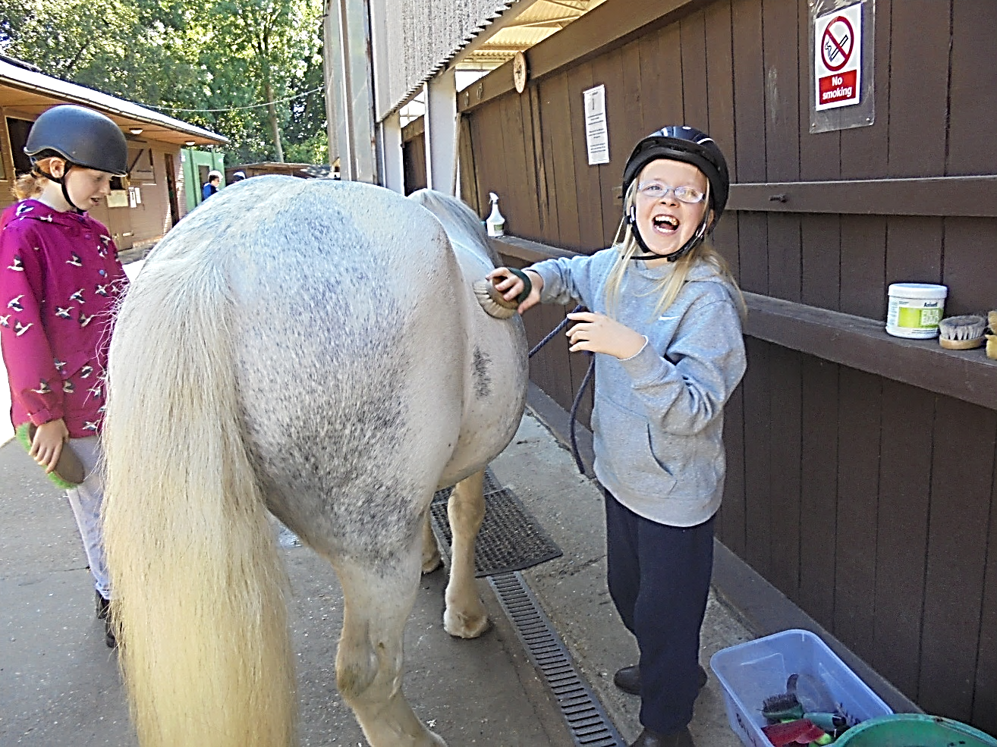

What is the goal of equine therapy?
At the beginning, equine therapy sessions will focus on helping you overcome any initial uneasiness, empowering you to develop and nurture your relationship with the horse.
Working with horses requires patience, understanding, discipline and responsibility. Horses can be stubborn one day and playful the next, meaning that you need to be flexible, innovative and open to altering your behaviour.
By working through equine therapy, you can develop skills such as communication, self-control, problem solving and accountability, as well as improve your self-esteem, empathy, flexibility and independence.
It gives you the opportunity to discover more about your capabilities develop new ways of thinking and change negative behaviours. For example, by working with the horse, you may start to notice self-defeating thought processes or negative patterns of behaviour, giving you the opportunity to take steps to overcome them.

What are the benefits of equine therapy?
Many of the benefits are likely due to the nature of the horses themselves. Horses are naturally gentle and calm creatures, and are able to mirror and respond to human behaviour, meaning that they are highly effective at interacting and working with others in a patient and non-judgemental manner.
Those who struggle to articulate how they’re feeling often find equine therapy useful as they’re able to express their emotions and feelings with their horse. In addition, individuals who find it hard to trust others or be intimate with people, can often achieve a strong bond and a level of closeness with their horse, and experience affection, acceptance and mutual respect.
Equine therapy doesn’t just result in psychological benefits - it has physical benefits too. Equine therapy has been found to reduce people’s blood pressure and heart rate, and help to calm physical symptoms of conditions such as anxiety and stress.
