7KP | Monday | Tuesday | Wednesday | Thursday | Friday
9:15 – 9:30  Pastoral | Pastoral  Room 6 | Pastoral  Room 6 | Assembly  Hall | Hymn Practice  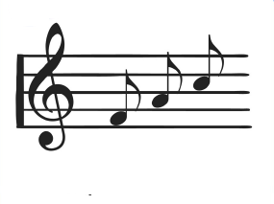  Hall | Assembly  Hall
9:30 – 10:15  Lesson 1 | English  Room 6 | English  Room 6 | Food  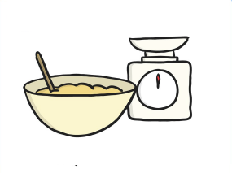  Room 9 | Music  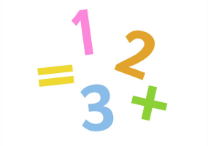  GS2 | English Reflection  Room 6
10:15 – 11:00  Lesson 2 | English  Room 6  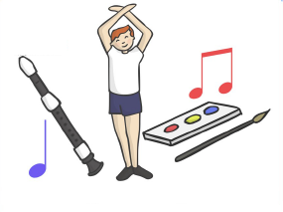 | English  Room 6 | Food  Room 9 | Dance  Hall | Humanities  Room 12
11:00 – 11:15  Break |  | 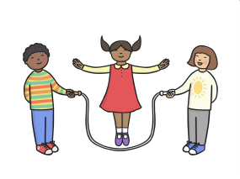
11:15 – 12:05  Lesson 3 | Maths  Room 6 | Maths  Room 6 | Maths  Room 6 | Maths  Room 6 | Humanities  Room 12
12:05 – 1:00
Lunchtime
1:00 – 1:45  Lesson 4 | Art  Room 6 | Rural Studies  Farm | Maths  Room 6 | Science  Room 8 | PE  Hall
1:45 – 2:30  Lesson 5 | Art  Room 6 | Rural Studies  Farm | PSHCE/SEAL  Room 6 | Science  Room 8 | DT  Room 11
2:30 – 3:10  Lesson 6 | PE  Hall  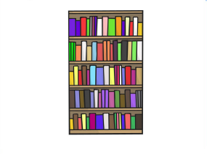 | Library  Library | Computing  Room 1 | English  Room 6 | DT  Room 11
3:15
Home Time
Weatherfield Academy 2017 - 2018
Weatherfield Academy 2015-2016
Weatherfield Academy 2015-2016

